Supplementary information

Repetitive calls in Southern House Wrens: information encoded in the number and rate of alarm calls

Gustavo J. Fernández^{1*} & Mariana E. Carro¹

¹Grupo de Investigación en Ecofisiología de Fauna Silvestre, INIBIOMA-CONICET, Asentamiento Universitario San Martín de los Andes (AUSMA). Universidad Nacional del Comahue, Pasaje de la Paz 235, (8370) San Martín de los Andes, Neuquén, Argentina

*gjf.sma@gmail.com

Figure S1. Satellite image showing the study site located near San Martín de los Andes, Neuquén, Argentina. The yellow crosses indicate the approximate locations of the sampling sites.
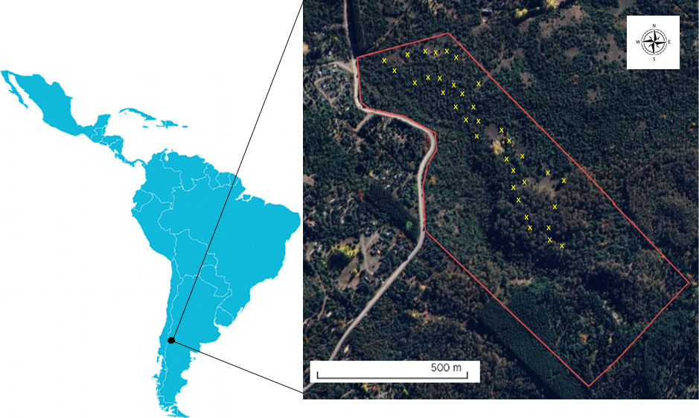

Table S1. Tables of effects recorded during the experiment testing calling rate and call length variation in the House Wren (Troglodytes musculus).
Model: [response variable] = Calling rate + Call length + Calling rate x Call length + Date + (1|Site)

Response probability
Effect | Chi-squared | df | p | p _{adj}
Calling rate x Call length | 0.03 | 1 | 0.86
Call length | 4.75 | 1 | 0.03 | 0.05
Calling rate | 11.17 | 1 | <0.01 | < 0.01

Latency to respond
Effect | Chi-squared | df | p | p _{adj}
Calling rate x Call length | 2.40 | 1 | 0.12
Call length | 0.63 | 1 | 0.43
Calling rate | 16.94 | 1 | <0.01 | <0.01

Time remaining less than10 m from the speaker
Raw model:
Effect | Chi-squared | df | p | p _{adj}
Calling rate x Call length | 0.23 | 1 | 0.62
Call length | 5.16 | 1 | 0.02 | 0.05
Calling rate | 10.25 | 1 | <0 .01 | < 0.01

IPW model:
Effect | Chi-squared | df | p | p _{adj}
Calling rate x Call length | 0.51 | 1 | 0.47
Call length | 3.83 | 1 | 0.05 | 0.08
Calling rate | 12.63 | 1 | < 0.01 | <0 .01

Time remaining less than 5 m from the speaker
Raw model:
Effect | Chi-squared | df | p | p _{adj}
Calling rate x Call length | 0.08 | 1 | 0.77
Call length | 3.34 | 1 | 0.07
Calling rate | 2.63 | 1 | 0.10

IPW model:
Effect | Chi-squared | df | p | p _{adj}
Calling rate x Call length | 0.10 | 1 | 0.75
Call length | 3.69 | 1 | 0.05 | 0.08
Calling rate | 3.05 | 1 | 0.08

Minimum distance from the speaker
Raw model:
Effect | Chi-squared | df | p
Calling rate x Call length | 3.09 | 1 | 0.08
Call length | 1.25 | 1 | 0.26
Calling rate | 2.44 | 1 | 0.11

IPW model:
Effect | Chi-squared | df | p | p _{adj}
Calling rate x Call length | 5.24 | 1 | 0.02 | 0.05

